

Information Technology Department

CCS0007
(Computer Programming 2)

MACHINE PROBLEM
1

Structures

Name: Justine Guillermo | Professor: Jay-Ar Lalata
Date Performed : 02/01/19 | Date Submitted:02/01/19

PROBLEM:

A small computer hardware company maintains an inventory consisting of five products; motherboards, hard disk, flash disk, compact disk, and memory cards. Write a program to keep track of the inventory, add items to the inventory and remove items from the inventory. Organize the program around a loop in which the user is asked to make choice from a menu. There are three choices: Add items, Remove items and Quit.

Directions: Given the program below complete the //do this portion of the program and make it run correctly based on the sample output given.

Program:

#include<iostream>
using namespace std;

struct Product{
int M;
int H;
int D;
int C;
int MC;
} P;

void AddItem(int inp,int u,Product &P){
//do this
}

void RemoveItem(int inp,int u,Product &P){
//do this
}

main(){
int opt,inp,u;

P.M=50;
P.H=50;
P.D=50;
P.C=50;
P.MC=50;

do{
cout<<"\n\nIdentification Number\tProduct\t\tQuantity\n";
cout<<"\t1\t\tMotherboards\t"<<P.M<<"\n";
cout<<"\t2\t\tHard Disk\t"<<P.H<<"\n";
cout<<"\t3\t\tDiskette\t"<<P.D<<"\n";
cout<<"\t4\t\tCompact Disk\t"<<P.C<<"\n";
cout<<"\t5\t\tMemory Cards\t"<<P.MC<<"\n";
cout<<"Choices:";
cout<<"\n1 - Add Item";
cout<<"\n2 - Remove Item";
cout<<"\n3 - Quit";
cout<<"\nChoose an operation to perform(1-3): ";
cin>>opt;
switch(opt){
case 1: //do this
break;
case 2: cout<<"Enter the identification number of the item you wish to add(1-5): ";
cin>>inp;
cout<<"Number of units to be removed: ";
cin>>u;
RemoveItem(inp,u,P);

break;
case 3: //do this
default: //do this

}
}
while(opt!=3);

}

Sample Output:

Add Item

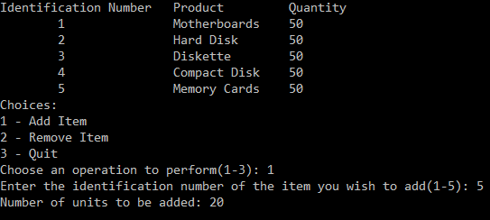

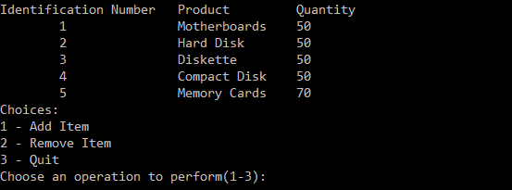

Remove Item

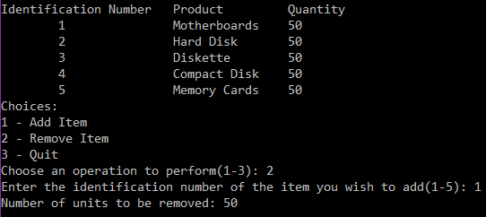

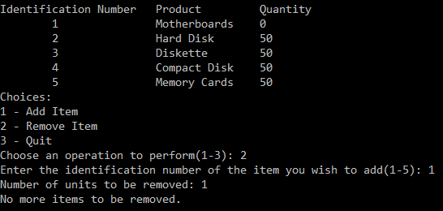

Quit
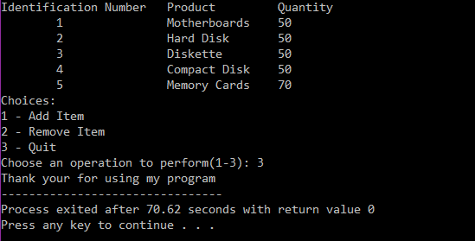

Wrong Input

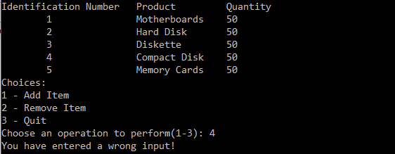

Complete Correct Program: (Paste your complete program here)
#include<iostream>
using namespace std;

struct Product{
int M;
int H;
int D;
int C;
int MC;
} P;

void AddItem(int inp,int u,Product &P){//do this

switch (inp){

case 1:
for (u<u-1;u--;)
P.M++;
break;
case 2:
for (u<u-1;u--;)
P.H++;
break;
case 3:
for (u<u-1;u--;)
P.D++;
break;
case 4:
for (u<u-1;u--;)
P.C++;
break;
case 5:
for (u<u-1;u--;)
P.MC++;
break;

}

}

void RemoveItem(int inp,int u,Product &P){//do this

switch (inp){

case 1:
if(P.M==0)
cout << "no more items to be removed";
else
for (u<u-1;u--;)
P.M--;
break;
case 2:
if(P.H==0)
cout << "no more items to be removed";
else
for (u<u-1;u--;)
P.H--;
break;
case 3:
if(P.D==0)
cout << "no more items to be removed";
else
for (u<u-1;u--;)
P.D--;
break;
case 4:
if(P.C==0)
cout << "no more items to be removed";
else
for (u<u-1;u--;)
P.C--;
break;
case 5:
if(P.MC==0)
cout << "no more items to be removed";
else
for (u<u-1;u--;)
P.MC--;
break;

}
}

main(){
int opt,inp,u;

P.M=50;
P.H=50;
P.D=50;
P.C=50;
P.MC=50;

do{
cout<<"\n\nIdentification Number\tProduct\t\tQuantity\n";
cout<<"\t1\t\tMotherboards\t"<<P.M<<"\n";
cout<<"\t2\t\tHard Disk\t"<<P.H<<"\n";
cout<<"\t3\t\tDiskette\t"<<P.D<<"\n";
cout<<"\t4\t\tCompact Disk\t"<<P.C<<"\n";
cout<<"\t5\t\tMemory Cards\t"<<P.MC<<"\n";
cout<<"Choices:";
cout<<"\n1 - Add Item";
cout<<"\n2 - Remove Item";
cout<<"\n3 - Quit";
cout<<"\nChoose an operation to perform(1-3): ";
cin>>opt;
switch(opt){
case 1: //do this
cout<<"Enter the identification number of the item you wish to add(1-5): ";
cin>>inp;
cout<<"Number of units to be added: ";
cin>>u;
AddItem (inp,u,P);

break;
case 2:
cout<<"Enter the identification number of the item you wish to add(1-5): ";
cin>>inp;
cout<<"Number of units to be removed: ";
cin>>u;
RemoveItem(inp,u,P);

break;
case 3: //do this
cout << "Thank you for using my program";

return 0;
default: //do this
cout << "You have entered a wrong input!"<<endl;
system ("pause");

}
}
while(opt!=3);

}

Sample Output: (Paste your sample output here. Include options Add Item, Remove Item, Quit and Wrong Input)

ADD ITEM
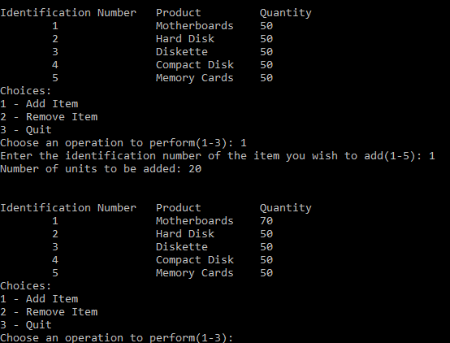

Remove item
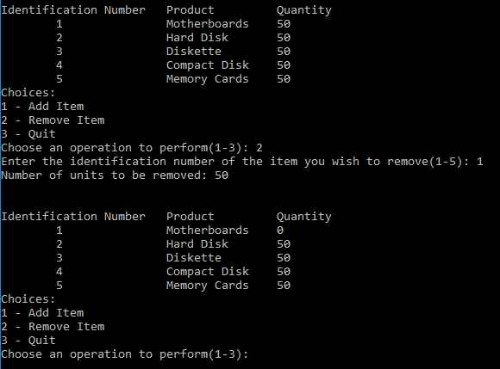

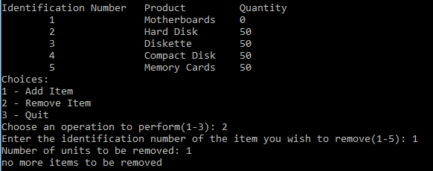

QUIT

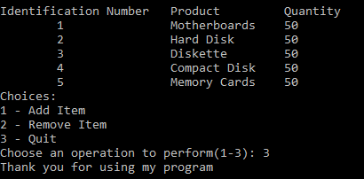

WRONG INPUT
